P. Salma

192110570

1. Write a C program for Caesar cipher involves replacing each letter of the alphabet with the letter standing k place further down the alphabet, for k in range 1 through 25.

Code:

#include <stdio.h>

#include <string.h>

int encrypt(char message[], int key) {

int i;

char ch;

for(i = 0; message[i] != '\0'; ++i) {

ch = message[i];

if(ch >= 'a' && ch <= 'z') {

ch = ch + key;

if(ch > 'z') {

ch = ch - 'z' + 'a' - 1;

}

message[i] = ch;

}

else if(ch >= 'A' && ch <= 'Z') {

ch = ch + key;

if(ch > 'Z') {

ch = ch - 'Z' + 'A' - 1;

}

message[i] = ch;

}

}

}

int decrypt(char message[], int key) {

encrypt(message, -key);

}

int main() {

char message[100];

int key;

printf("Enter a message: ");

gets(message);

printf("Enter the key (an integer): ");

scanf("%d", &key);

encrypt(message, key);

printf("Encrypted message: %s\n", message);

decrypt(message, key);

printf("Decrypted message: %s\n", message);

return 0;

}

Output:

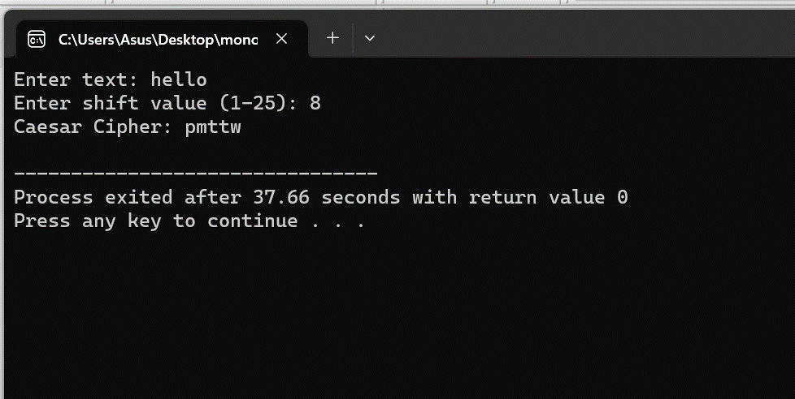

1. Write a C program for monoalphabetic substitution cipher maps a plain text alphabet to a ciphertext alphabet so that each letter of the plaintext alphabet maps to ingle unique letter of the ciphertext alphabet.

Code:

#include <stdio.h>

#include <string.h>

void caesarCipher(char *text, int shift) {

for (int i = 0; i < strlen(text); i++) {

char c = text[i];

if (c >= 'a' && c <= 'z') {

text[i] = 'a' + (c - 'a' + shift) % 26;

} else if (c >= 'A' && c <= 'Z') {

text[i] = 'A' + (c - 'A' + shift) % 26;

}

}

}

int main() {

char text[100];

int shift;

printf("Enter text: ");

gets(text);

printf("Enter shift value (1-25): ");

scanf("%d", &shift);

if (shift >= 1 && shift <= 25) {

caesarCipher(text, shift);

printf("Caesar Cipher: %s\n", text);

} else {

printf("Shift value must be between 1 and 25.\n");

}

return 0;

}

Output:



1. Write a C program for playfair algorithm is based on the use of a 5*5 matrix of letters constructed using a keyword plaintext is encrypted two letters at time using this matrix.

Code:

#include <stdio.h>

#include <string.h>

#include <ctype.h>

void constructMatrix(char key[], char matrix[5][5]) {

int k, flag = 0;

char table[26] = {0};

int keylen = strlen(key);

for (k = 0; k < keylen; k++) {

if (key[k] == 'J')

key[k] = 'I';

key[k] = toupper(key[k]);

if (table[key[k] - 'A'] == 0) {

table[key[k] - 'A'] = 1;

matrix[flag / 5][flag % 5] = key[k];

flag++;

}

}

for (k = 0; k < 26; k++) {

if (table[k] == 0) {

matrix[flag / 5][flag % 5] = (char)('A' + k);

flag++;

}

}

}

void findPosition(char matrix[5][5], char ch, int *row, int *col) {

if (ch == 'J')

ch = 'I';

int i, j;

for (i = 0; i < 5; i++) {

for (j = 0; j < 5; j++) {

if (matrix[i][j] == ch) {

*row = i;

*col = j;

return;

}

}

}

}

void encrypt(char matrix[5][5], char plaintext[], char ciphertext[]) {

int len = strlen(plaintext);

for (int i = 0; i < len; i += 2) {

char ch1 = plaintext[i];

char ch2 = plaintext[i + 1];

int row1, col1, row2, col2;

findPosition(matrix, ch1, &row1, &col1);

findPosition(matrix, ch2, &row2, &col2);

if (row1 == row2) {

ciphertext[i] = matrix[row1][(col1 + 1) % 5];

ciphertext[i + 1] = matrix[row2][(col2 + 1) % 5];

} else if (col1 == col2) {

ciphertext[i] = matrix[(row1 + 1) % 5][col1];

ciphertext[i + 1] = matrix[(row2 + 1) % 5][col2];

} else {

ciphertext[i] = matrix[row1][col2];

ciphertext[i + 1] = matrix[row2][col1];

}

}

}

int main() {

char key[] = "KEYWORD";

char matrix[5][5];

char plaintext[] = "HELLO";

char ciphertext[100];

constructMatrix(key, matrix);

encrypt(matrix, plaintext, ciphertext);

printf("Encrypted text: %s\n", ciphertext);

return 0;

}

Output:

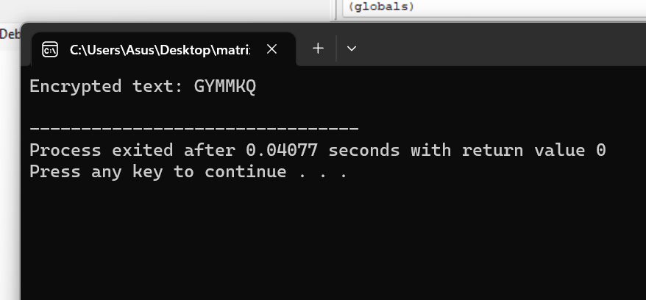

1. Write a C program for polyalphabetic substitution cipher uses a separate monoalphabetic substitution cipher for each successive letter of plaintext, depending on a key.

Code:

#include <stdio.h>

#include <string.h>

void polyalphabeticCipher(char plaintext[], char key[]) {

int i, j;

int plaintextLength = strlen(plaintext);

int keyLength = strlen(key);

for (i = 0; i < plaintextLength; i++) {

char currentChar = plaintext[i];

char keyChar = key[i % keyLength];

char encryptedChar = 'A' + (currentChar - 'A' + keyChar - 'A') % 26;

printf("%c", encryptedChar);

}

printf("\n");

}

int main() {

char plaintext[100];

char key[100];

printf("Enter the plaintext: ");

scanf("%s", plaintext);

printf("Enter the key: ");

scanf("%s", key);

printf("Encrypted Text: ");

polyalphabeticCipher(plaintext, key);

return 0;

}

Output:

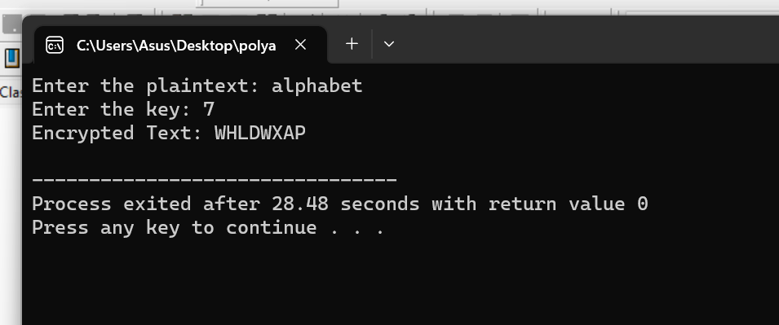

1. Write a C program for generalization of the caser cipher, known as the affine caser cipher, has the following form: For each plaintext letter p, substitute the ciphertext letter c:c=E([a,b, p) = (ap + b) mod 26 A basic requirement of any encryption algorithm is that it be one-to-one. That is, if p q, then E(k, p) E(k, q). Otherwise, decryption is impossible, because more than one plaintext character maps into the same ciphertext character. The affine Caesar cipher is not one-to-one for all values of a. For example, for a = 2 and b = 3, then E([a, b], 0) = E([a, b], 13) = 3.

a. Are there any limitations on the value of b?

b. Determine which values of a are not allowed.

Code:

#include <stdio.h>

#include <string.h>

char decrypt(char ch, int a, int b) {

if (ch >= 'A' && ch <= 'Z') {

return ((ch - 'A' - b + 26) * 15) % 26 + 'A';

} else if (ch >= 'a' && ch <= 'z') {

return ((ch - 'a' - b + 26) * 15) % 26 + 'a';

} else {

return ch;

}

}

int main() {

char ciphertext[] = "your_cipher_text_here";

char mostFrequentLetter = 'b';

char secondMostFrequentLetter = 'U';

int a, b;

b = (mostFrequentLetter - secondMostFrequentLetter + 26) % 26;

for (a = 1; a < 26; a++) {

printf("a = %d, b = %d: ", a, b);

for (int i = 0; i < strlen(ciphertext); i++) {

char decrypted = decrypt(ciphertext[i], a, b);

printf("%c", decrypted);

}

printf("\n");

}

return 0;

}

Output:

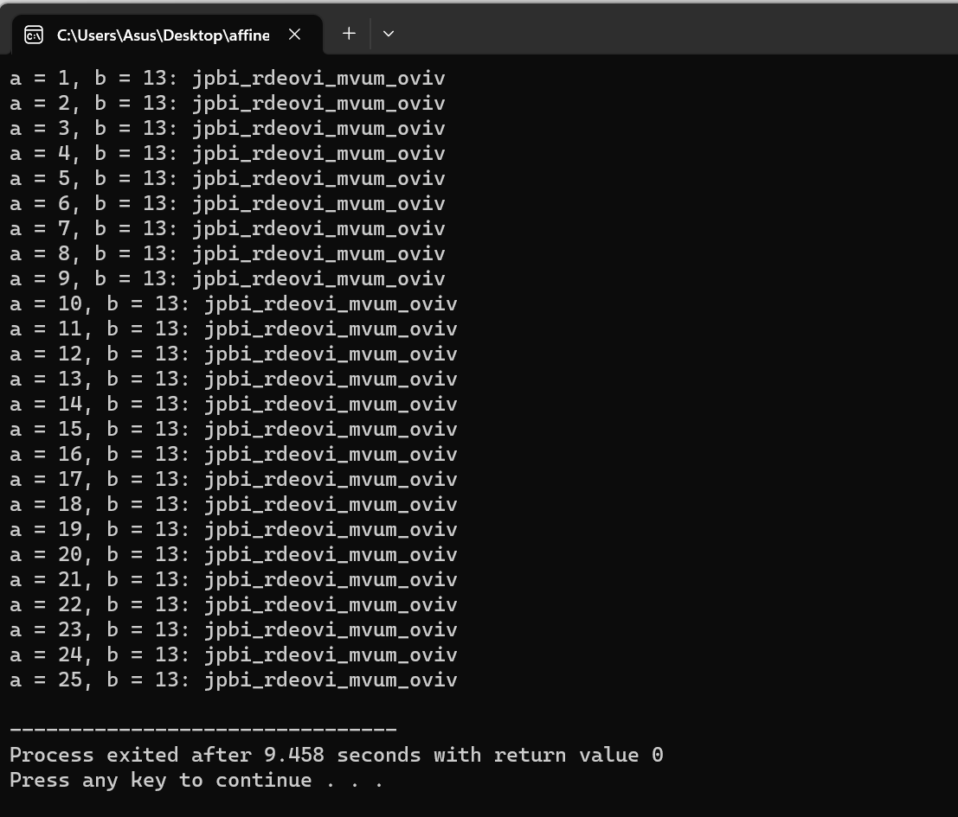

1. Write a C program for ciphertext has been generated with an affine cipher. The most frequent letter of the ciphertext is “B”, and the second most frequent letter of the ciphertext is “U.” break this code.

Code:

#include <stdio.h>

int gcd(int a, int b) {

if (b == 0)

return a;

return gcd(b, a % b);

}

int is_allowed_a(int a) {

return gcd(a, 26) == 1;

}

int main() {

int a, b;

printf("Enter the value of 'a': ");

scanf("%d", &a);

if (!is_allowed_a(a)) {

printf("Value of 'a' is not allowed. It must be relatively prime to 26.\n");

return 1;

}

printf("Enter the value of 'b': ");

scanf("%d", &b);

if (b < 0 || b >= 26) {

printf("Value of 'b' is not allowed. It must be in the range [0, 25].\n");

return 1;

}

char plaintext;

printf("Enter the plaintext character: ");

scanf(" %c", &plaintext);

if (plaintext >= 'A' && plaintext <= 'Z') {

char ciphertext = 'A' + ((a * (plaintext - 'A') + b) % 26);

printf("Ciphertext: %c\n", ciphertext);

} else if (plaintext >= 'a' && plaintext <= 'z') {

char ciphertext = 'a' + ((a * (plaintext - 'a') + b) % 26);

printf("Ciphertext: %c\n", ciphertext);

} else {

printf("Invalid input. Please enter an uppercase or lowercase letter.\n");

return 1;

}

return 0;

}

Output:

